Module 5 - Spring Core and Maven
Exercise 1: Configuring a Basic Spring Application
Program Code:
Project Structure:
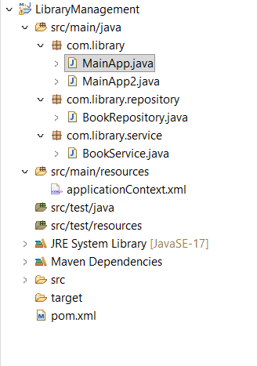
pom.xml:
<project xmlns="http://maven.apache.org/POM/4.0.0"
xmlns:xsi="http://www.w3.org/2001/XMLSchema-instance"
xsi:schemaLocation="http://maven.apache.org/POM/4.0.0 https://maven.apache.org/xsd/maven-4.0.0.xsd">
<modelVersion>4.0.0</modelVersion>
<groupId>com.library</groupId>
<artifactId>LibraryManagement</artifactId>
<version>0.0.1-SNAPSHOT</version>

<dependencies>
<dependency>
<groupId>org.springframework</groupId>
<artifactId>spring-context</artifactId>
<version>6.1.10</version> </dependency>
</dependencies>

<build>
<plugins>
<plugin>
<groupId>org.apache.maven.plugins</groupId>
<artifactId>maven-compiler-plugin</artifactId>
<version>3.11.0</version>
<configuration>
<source>17</source>
<target>17</target>
</configuration>
</plugin>
</plugins>
</build>
</project>

applicationContext.xml :
<bean id="bookRepository" class="com.library.repository.BookRepository" />
<bean id="bookService" class="com.library.service.BookService" />

BookRepository class :
package com.library.repository;

public class BookRepository {
public void saveData() {
System.out.println("Book data saved successfully to the database!");
}
}

BookService class :

package com.library.service;

import com.library.repository.BookRepository;

public class BookService {
private BookRepository bookRepository;

// Setter method for Spring to inject BookRepository
public void setBookRepository(BookRepository bookRepository) {
this.bookRepository = bookRepository;
}

public void addBook() {
System.out.println("Service: Attempting to add a book...");
bookRepository.saveData();
}
}

MainApp.java:
package com.library;

import org.springframework.context.ApplicationContext;
import org.springframework.context.support.ClassPathXmlApplicationContext;
import com.library.repository.BookRepository;

public class MainApp {
public static void main(String[] args) {
System.out.println("--- Exercise 1: Initializing Spring Context ---");

// 1. Load the Spring XML configuration file to start the IoC Container
ApplicationContext context = new ClassPathXmlApplicationContext("applicationContext.xml");

System.out.println("Spring Context loaded successfully!");

// 2. Retrieve the BookRepository bean directly from the container to test configuration
BookRepository bookRepository = (BookRepository) context.getBean("bookRepository");

// 3. Call a method to verify the bean works
bookRepository.saveData();

// Close the context resource
((ClassPathXmlApplicationContext) context).close();
}
}

